Review
Write the following equations given the description
1.
2.
3. Graph the following
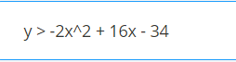
4.
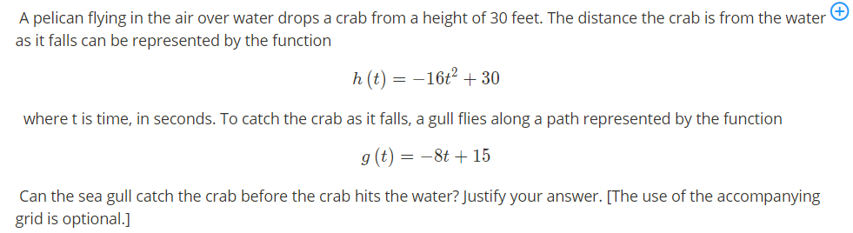
5.
